Name(s):
Invalidity Claim Chart — U.S. Patent No. 5,026,109 claim 1
U.S. Pat. No. 5,026,109 (Merlot) | U.S. Patent No. 4,189,178  (Cramaro) | U.S. Patent No. 3,415,260  (Hall)
1. A retractable segmented cover system used with a truck trailer comprising | “Tarpaulin cover system.” Title.  “A tarpaulin cover system for use in trucks eliminates the need for usual side tracks for guiding the tarpaulin supporting rods.” Abstract.  “This invention relates to a new tarpaulin cover system for use in a truck box. More particularly, the present invention relates to a tarpauline cover system suitable for vehicles such as dump trucks or the like, frequently used in hauling sand, gravel, rocks etc.” Col. 1, lines. 6–10.
a plurality of flexible cover sections with
a plurality of substantially parallel supporting bows spaced therebetween and |  | “A plurality of frames or arch members are independently movable between two fixed posts or support members and each is maintained in aligned parallelism by four cables, each cable being disposed in a Z-pulley arrangement.” Abstract, col. 1, lines 10–14.  Figure 1:  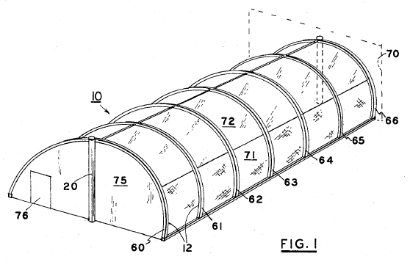  “Referring now to FIG. 1, it is to be noted that the structure embodies a plurality of frames, as for example, a first or forward frame and a first rightwardly adjacent frame 61. Other adjacent frames 62, 63, 64 and 65 are spaced rearwardly toward a rear frame 66, which frame may be attached to a wall indicated in phantom outline.” Col. 4, lines. 8–14.
a drive assembly,
wherein each cover section is detachably connected between substantially parallel supporting bows,
the bows are slideably supported on the truck trailer and
at least one bow is fixedly connected to the drive assembly such that the cover system can be extended or retracted by the drive assembly and
wherein a cover section can be removed from the cover system independent of the other cover sections.

